SCHOOL OF COMPUTER SCIENCE AND ARTIFICIAL INTELLIGENCE |  |  |  |  | DEPARTMENT OF COMPUTER SCIENCE ENGINEERING
ProgramName:B. Tech |  |  |  | Assignment Type: Lab |  |  | AcademicYear:2025-2026
CourseCoordinatorName |  |  |  | Venkataramana Veeramsetty
Instructor(s)Name
  Dr. V. Venkataramana (Co-ordinator)
  Dr. T. Sampath Kumar
  Dr. Pramoda Patro
  Dr. Brij Kishor Tiwari
  Dr.J.Ravichander
  Dr. Mohammand Ali Shaik
  Dr. Anirodh Kumar
  Mr. S.Naresh Kumar
  Dr. RAJESH VELPULA
  Mr. Kundhan Kumar
  Ms. Ch.Rajitha
  Mr. M Prakash
  Mr. B.Raju
  Intern 1 (Dharma teja)
  Intern 2 (Sai Prasad)
  Intern 3 (Sowmya)
  NS_2 ( Mounika)
CourseCode |  |  | 24CS002PC215 | CourseTitle |  | AI Assisted Coding
Year/Sem |  |  | II/I | Regulation |  | R24
Date and Day  of Assignment |  |  | Week3 - Wednesday | Time(s)
Duration |  |  | 2 Hours | Applicableto  Batches
AssignmentNumber:6.3(Present assignment number)/24(Total number of assignments)
NAME : MD. Rehana Tabassum
ROLLNO : 2503B05103
BATCH : M.Tech(CSE)
 | Q.No. | Question |  |  |  |  |  | ExpectedTime  to complete
 | 1 | Lab 6: AI-Based Code Completion – Classes, Loops, and Conditionals  Lab Objectives:  - To explore AI-powered auto-completion features for core Python constructs.  - To analyze how AI suggests logic for class definitions, loops, and conditionals.  - To evaluate the completeness and correctness of code generated by AI assistants.  Lab Outcomes (LOs):  After completing this lab, students will be able to:  - Use AI tools to generate and complete class definitions and methods.  - Understand and assess AI-suggested loops for iterative tasks.  - Generate conditional statements through prompt-driven suggestions.  - Critically evaluate AI-assisted code for correctness and clarity.  Task Description#1 (Classes)  - Use AI to complete a Student class with attributes and a method.  - Check output  - Analyze the code generated by AI tool  Expected Output#1  - Class with constructor and display_details() method  Prompt: Use AI to complete the class implementation, check the output by creating an object and calling the method, and then analyze the code line by line  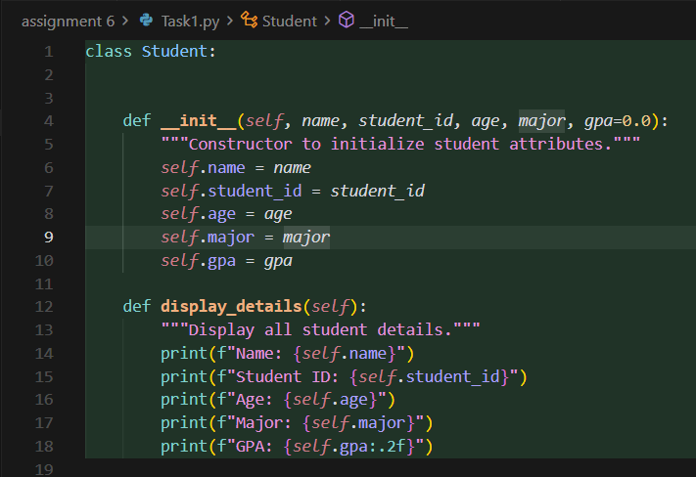  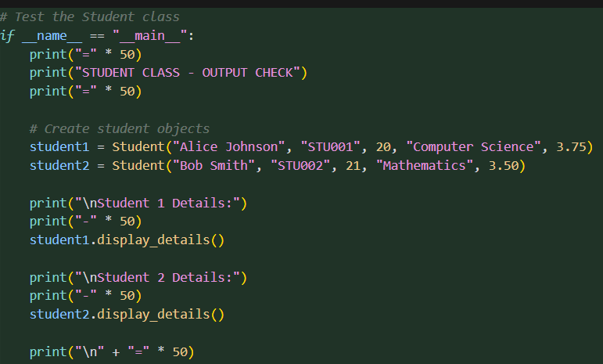  Code analysis:  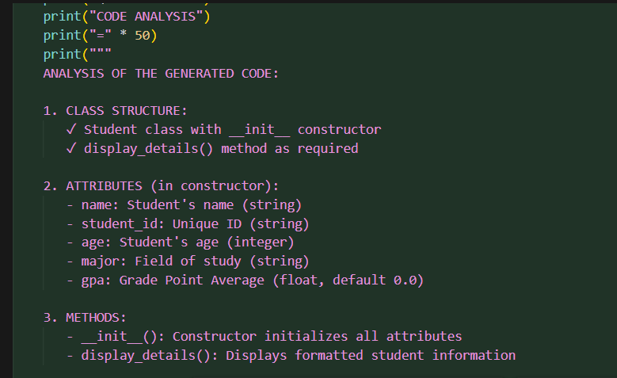 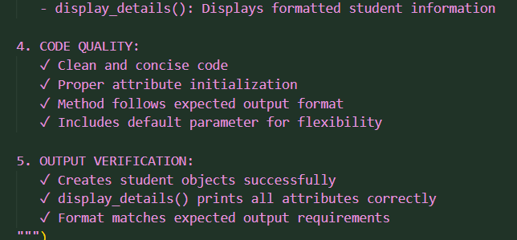output:  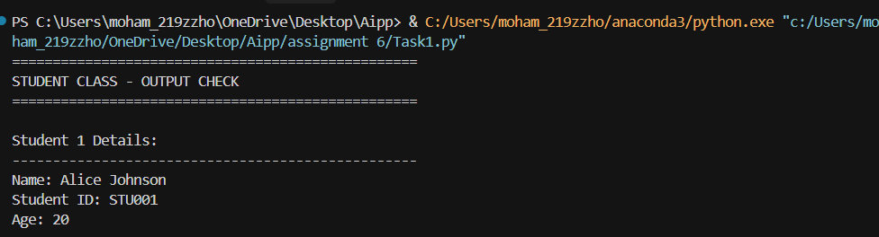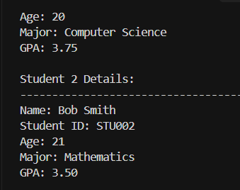  Task Description#2 (Loops)  - Prompt AI to complete a function that prints the first 10 multiples of a number using a loop.  - Analyze the generated code  - Ask AI to generate code using other controlled looping  Expected Output#2  - Correct loop-based implementation  Prompt:write a function that prnts the first 10 multiple ofa number using a loop analyze the code and generate the code using other controleed looping.  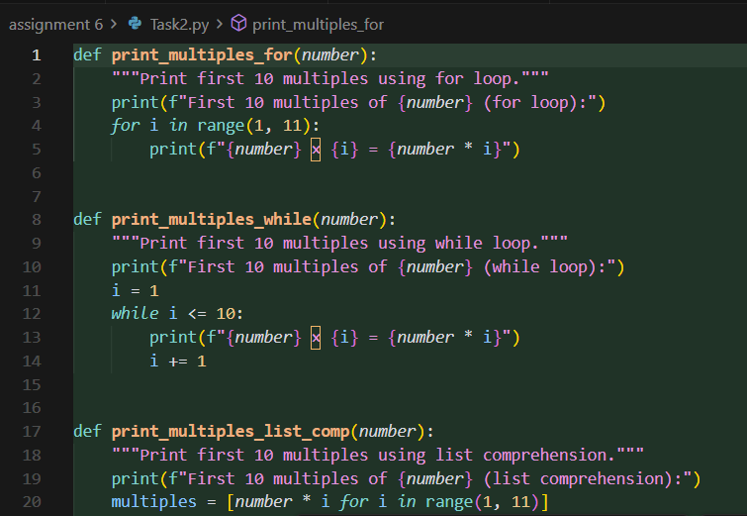  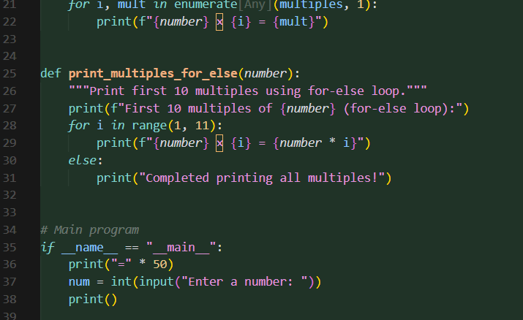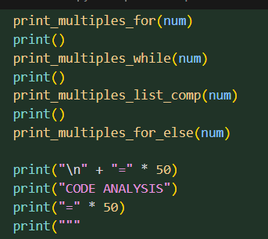  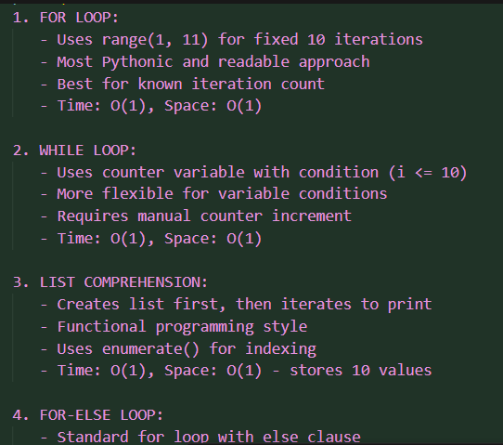  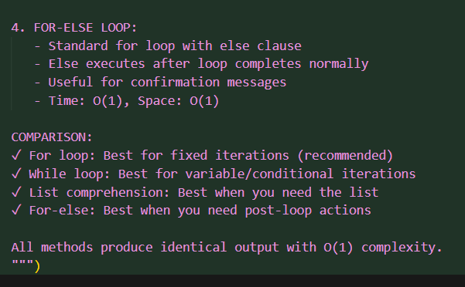  Output:  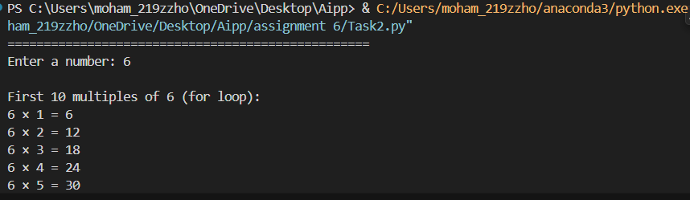  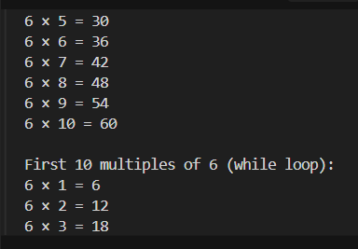  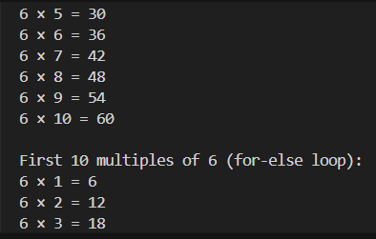Task 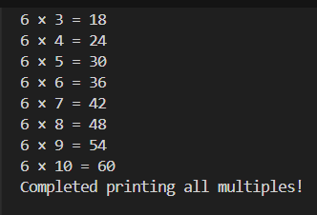  Description#3 (Conditional Statements)  - Ask AI to write nested if-elif-else conditionals to classify age groups.  - Analyze the generated code  - Ask AI to generate code using other conditional statements  Expected Output#3  - Age classification function with appropriate conditions and with explanation  Prompt: write a code onnested if-elif-else conditionals to classify age groups analyze the code and generate code using other conditional statement.  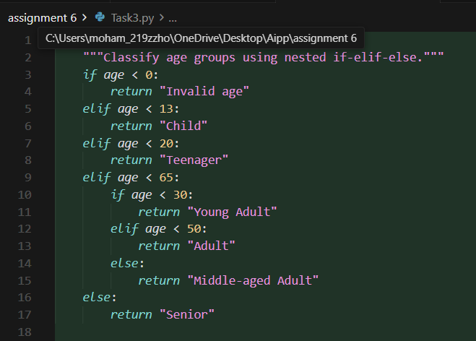  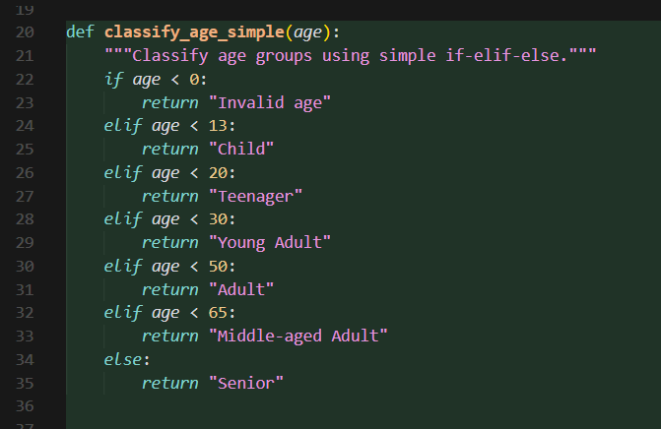  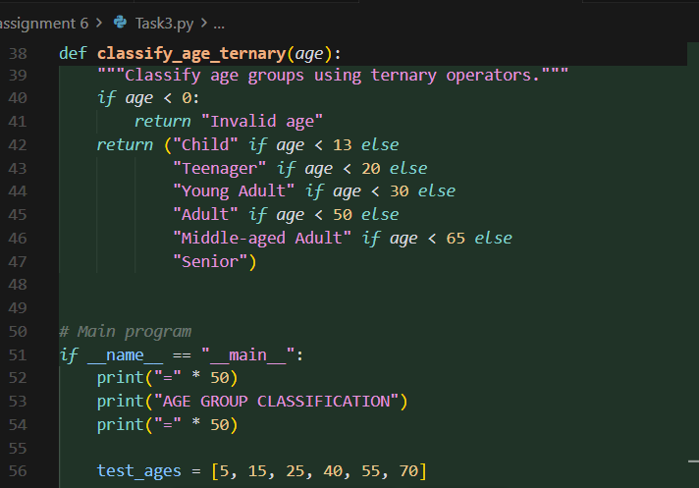  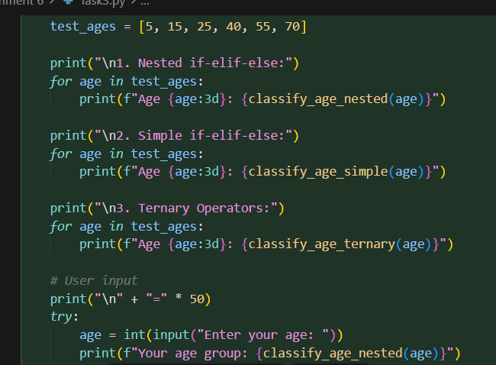  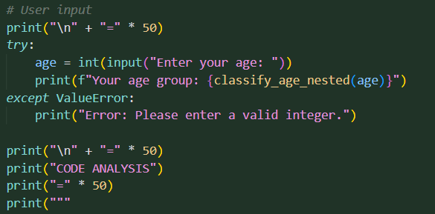  Code analysis:  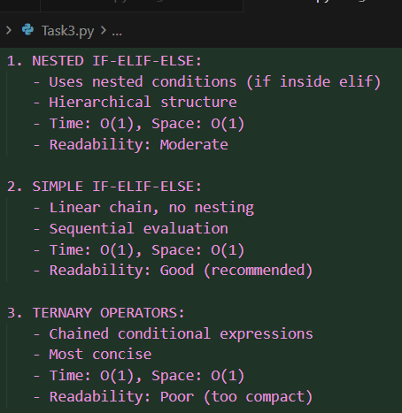 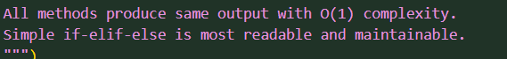 output:  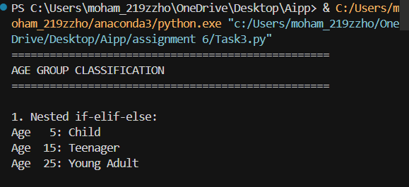  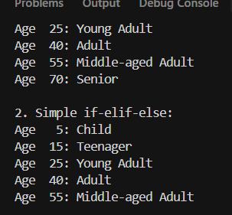  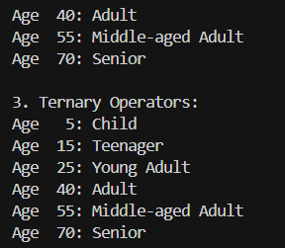  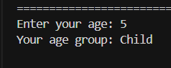  Task Description#4 (For and While loops)  - Generate a sum_to_n() function to calculate sum of first n numbers  - Analyze the generated code  - Get suggestions from AI with other controlled looping  Prompt: Write a Python program to calculate the sum of the first n natural numbers using a loop analyze code and generae program using other controlled looping.  Expected Output#4  - Python code with explanation  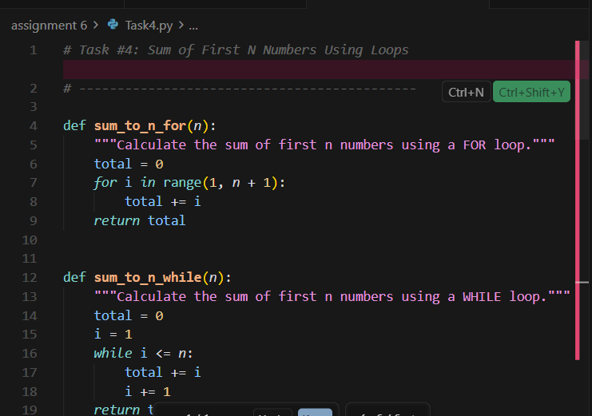  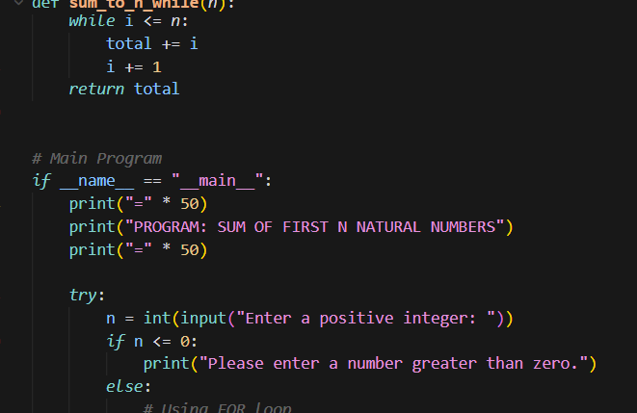 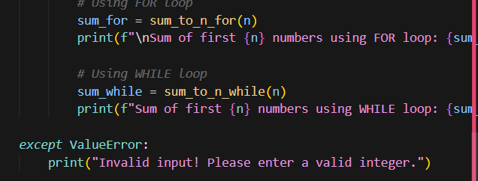 Analysis:  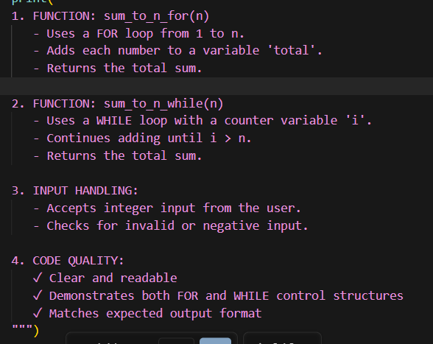  Output:  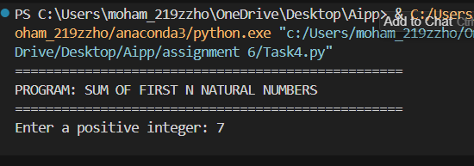  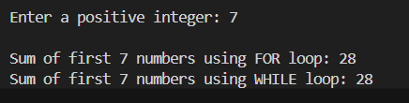 Task Description#5 (Class)  - Use AI to build a BankAccount class with deposit, withdraw, and balance methods.  - Analyze the generated code  - Add comments and explain code  Expected Output#5  - Python code with explanation  Prompt:Use ai to build a BankAccount class in Python that includes methods for deposit, withdraw, and displaying balance analyze code and add comments and explain code.  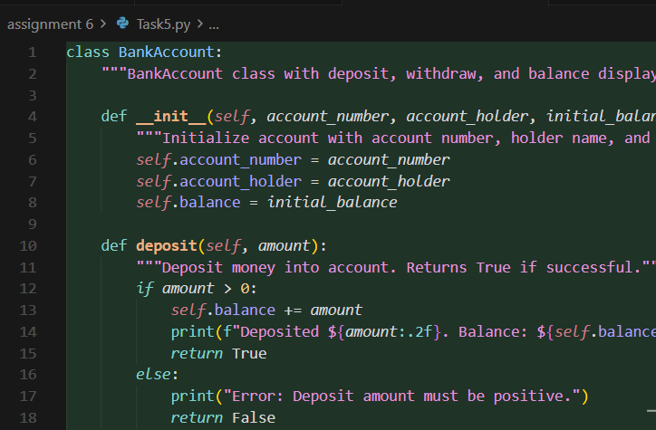  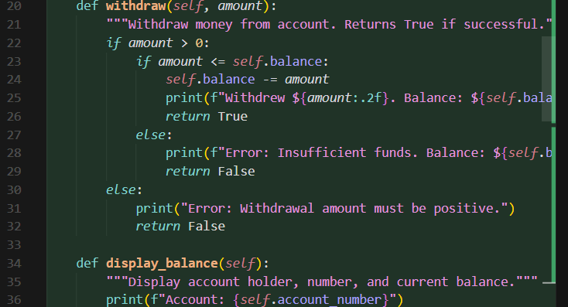  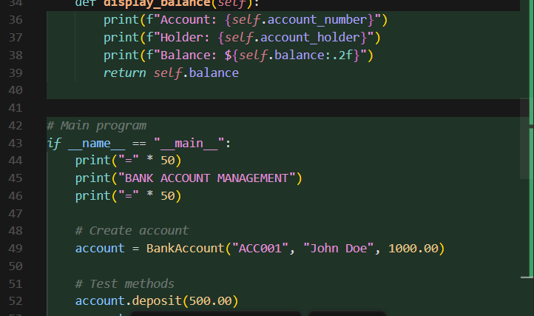  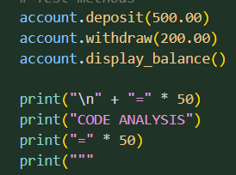  Code analysis:  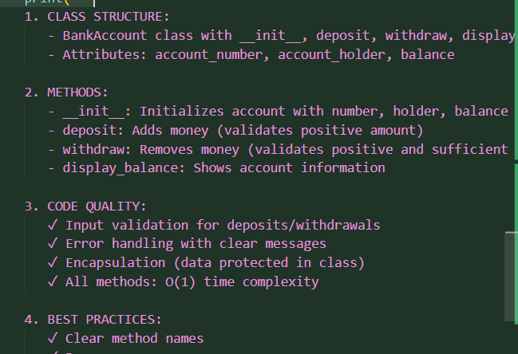  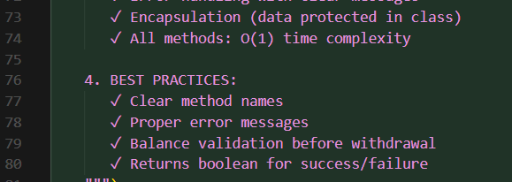  Output:  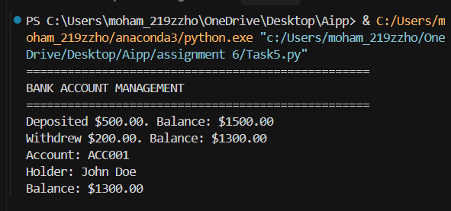Note: Report should be submitted a word document for all tasks in a single document with prompts, comments & code explanation, and output and if required, screenshots  Evaluation Criteria: |  |  |  |  |  | Week3 - Wednesday
  Criteria | Max Marks
  Class | 1.0
  Loops | 1.0
  Conditional Statements | 0.5
  Total | 2.5 Marks

